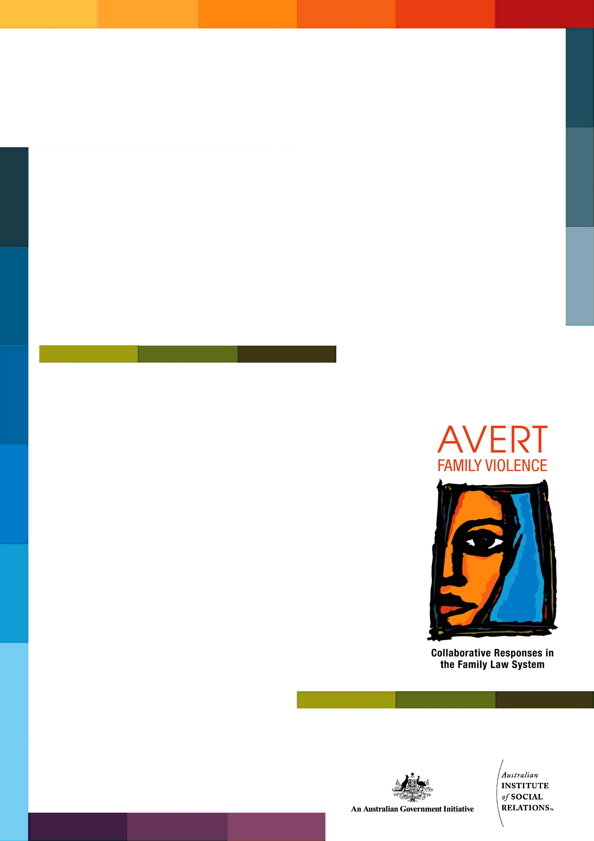
Fact Sheet
<Title>
Copyright
© Commonwealth of Australia 2010
This resource is protected by copyright. Apart from any use as permitted under the Copyright Act 1968, and those explicitly granted below, all other rights are reserved.
With the exception of the Commonwealth Coat of Arms and except where otherwise noted, all material presented in this training package is provided under a Creative Commons Attribution-No Derivative Works 3.0 Australia licence http://creativecommons.org/licenses/by-nd/3.0/au/legalcode. The terms under which the Coat of Arms can be used are detailed on the It's an Honour website http://www.itsanhonour.gov.au/coat-arms/.
For the avoidance of doubt, this means this licence only applies to material as set out in this training package.
You must include the following link: http://creativecommons.org/licenses/by-nd/3.0/au/legalcode when re-using or distributing this work so that it is clear to others that the Creative Commons licence applies to this copyright material.
The details of the relevant licence conditions are available on the Creative Commons website (accessible using the links provided) as is the full legal code for the CC BY-ND 3.0 AU licence http://creativecommons.org/licenses/by-nd/3.0/au/legalcode.
Any reference to, reuse or distribution of all or part of this training package must be attributed in the following way: Australian Attorney-General’s Department, AVERT Family Violence: Collaborative Responses in the Family Law System.

Contact us
Inquiries regarding the licence and any use of this resource are welcome at:
Assistant Secretary
Family Law Branch
Attorney-General’s Department
3-5 National Circuit
Barton ACT 2600

Disclaimer
The information presented and opinions expressed herein are those of the authors and do not necessarily represent the views of the Australian Government.




Heading 1 <Title of Factsheet>

Heading 2
Heading 3
Body text, body text, body text, body text, body text, body text, body text, body text, body text, body text body text
(Body text settings: arial 11pt, line spacing multiple at 1.2 with 6pt space before and after paragraphs).
- Bullet point first level
- Bullet point settings: arial 11pt, line spacing multiple at 1.2, 6pt space before and 10pt space after, left aligned at 0cm, hanging indent at 0.75cm.
- Bullet point second level
- Settings: arial 11 pt, multiple line spacing at 1.2, 6pt space before and 10pt space after, left aligned at 0.75cm, hanging indent at 1cm.

