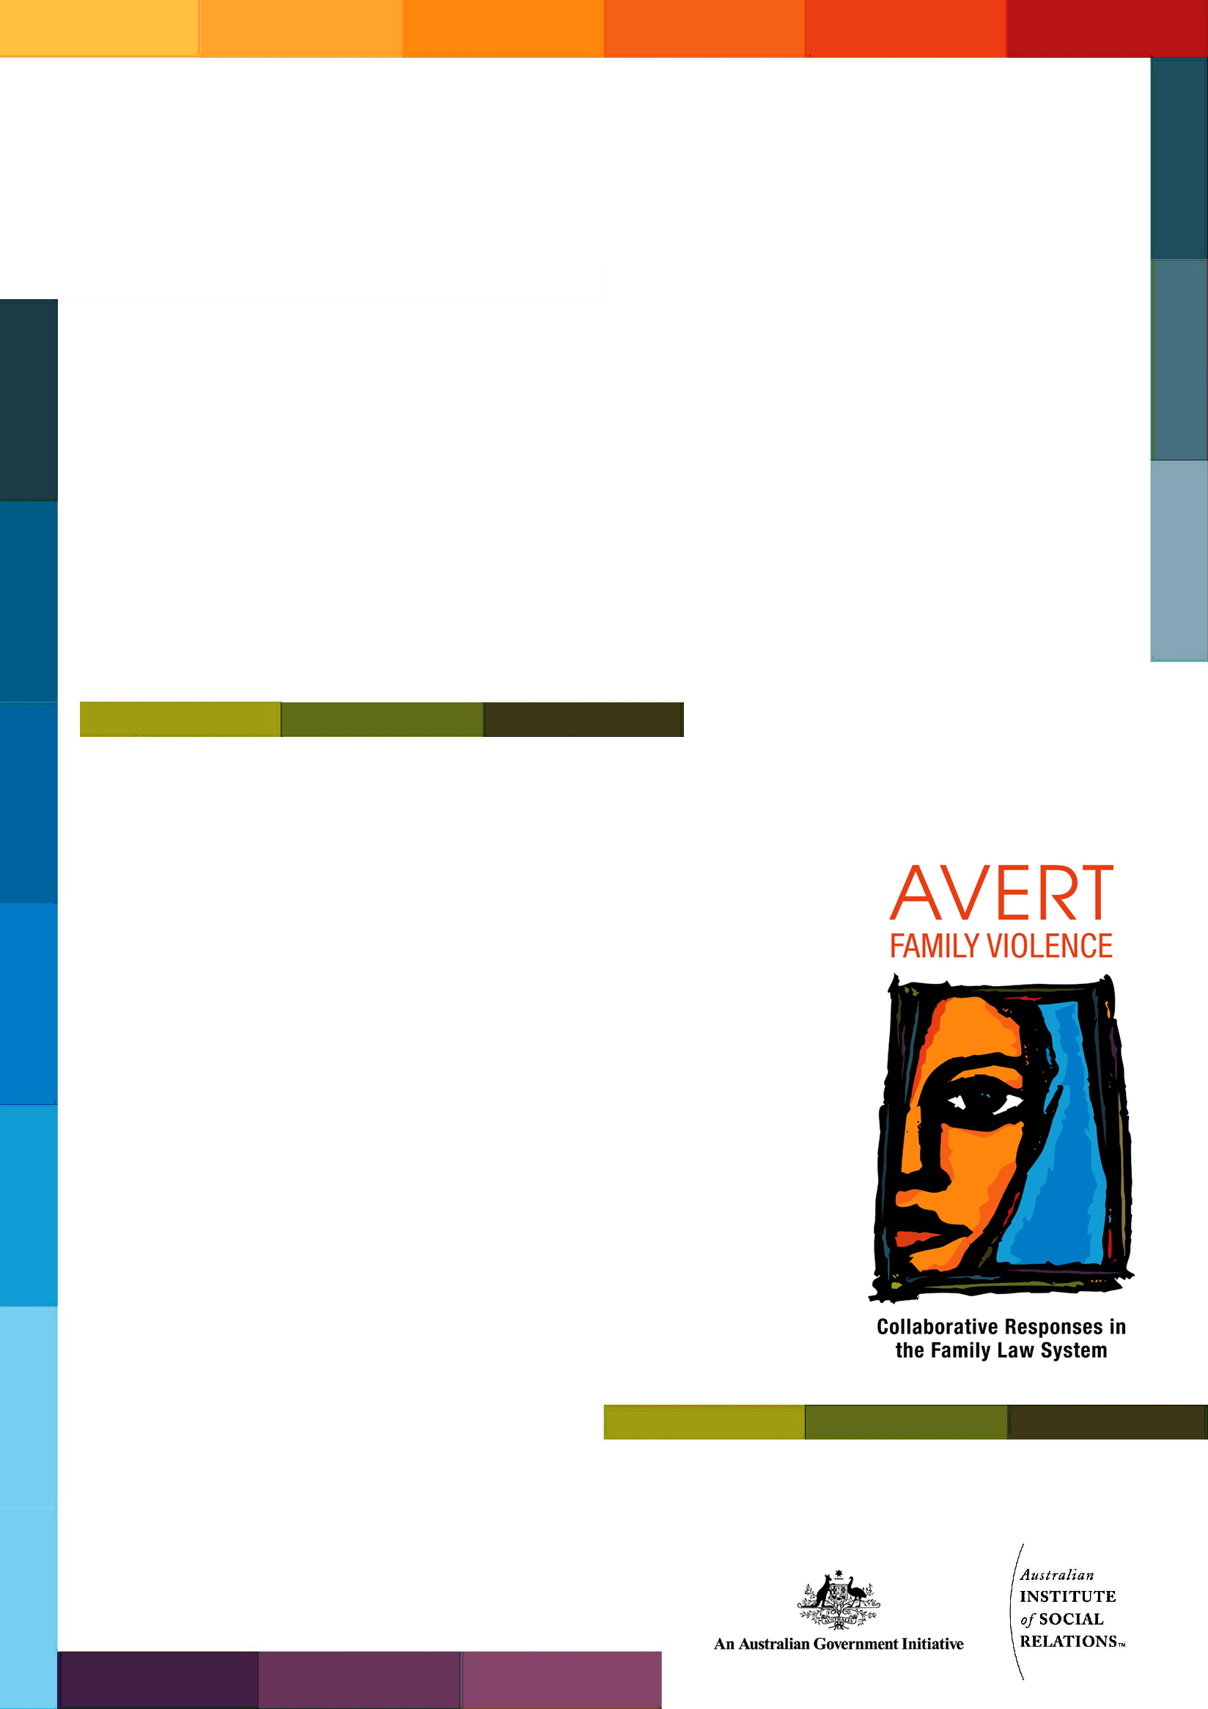
Training Session Plan
Responding to Cultural Diversity
One-Day Program

Copyright
© Commonwealth of Australia 2010
This resource is protected by copyright. Apart from any use as permitted under the Copyright Act 1968, and those explicitly granted below, all other rights are reserved.
With the exception of the Commonwealth Coat of Arms and except where otherwise noted, all material presented in this training package is provided under a Creative Commons Attribution-No Derivative Works 3.0 Australia licence http://creativecommons.org/licenses/by-nd/3.0/au/legalcode. The terms under which the Coat of Arms can be used are detailed on the It's an Honour website http://www.itsanhonour.gov.au/coat-arms/.
For the avoidance of doubt, this means this licence only applies to material as set out in this training package.
You must include the following link: http://creativecommons.org/licenses/by-nd/3.0/au/legalcode when re-using or distributing this work so that it is clear to others that the Creative Commons licence applies to this copyright material.
The details of the relevant licence conditions are available on the Creative Commons website (accessible using the links provided) as is the full legal code for the CC BY-ND 3.0 AU licence http://creativecommons.org/licenses/by-nd/3.0/au/legalcode.
Any reference to, reuse or distribution of all or part of this training package must be attributed in the following way: Australian Attorney-General’s Department, AVERT Family Violence: Collaborative Responses in the Family Law System.

Contact us
Inquiries regarding the licence and any use of this resource are welcome at:
Assistant Secretary
Family Law Branch
Attorney-General’s Department
3-5 National Circuit
Barton ACT 2600

Disclaimer
The information presented and opinions expressed herein are those of the authors and do not necessarily represent the views of the Australian Government.

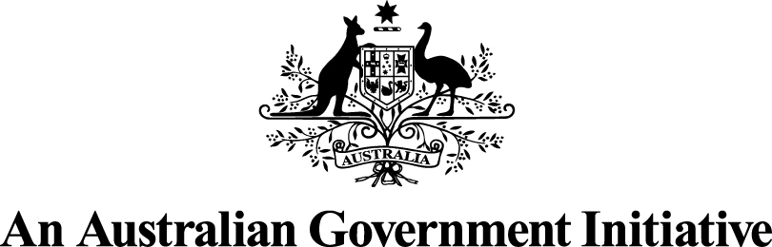
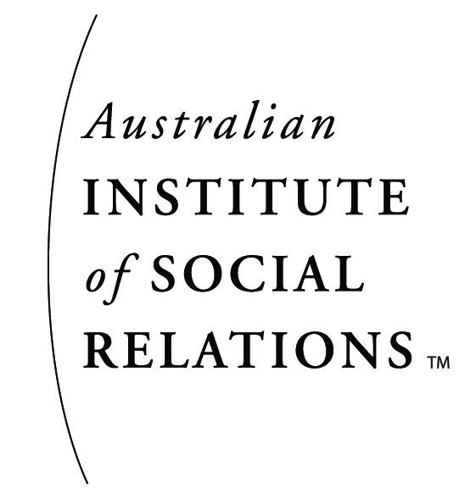

Training Session Plan - Responding to Cultural Diversity
Program Length: One day
Intended Participants: Professionals working within the Family Court System, or with related roles
NOTE: This program assumes participants have an understanding of family violence prior to attending the day. Those who do not may wish to attend the Dimensions, Dynamics and Impacts workshop in preparation. All participants should be encouraged to read the AVERT Paper: Dimensions, Dynamics and Impact of Family Violence as prior reading.

Program Learning Outcomes:

In the context of family violence:
- Increase understanding of the meaning of cultural diversity
- Shared knowledge of practices of cultural respect
- Explore the concept and impact of intersectionality
- Introduce a human rights perspective

Pre-Course Activities:

Ensure participants receive:
- Pre-course evaluation
- Pre-reading: AVERT Paper: Dimensions, Dynamics and Impact of Family Violence
- Pre-reading: AVERT Paper: Responding to Diversity

Room Setting and Equipment:

It is recommended that this program be run with a group size no bigger than 25 and the tables should be arranged in “Cabaret” style allowing participants to work in small groups. Equipment necessary for the program includes:
- Video projection
- Whiteboard
Facilitator Preparation:
The AVERT Family Violence Training Package is a multi-disciplinary training package that will be delivered to different professions with different skill sets. Facilitators should tailor the package for their particular audience and context. The package has been constructed with an assumption that an experienced trainer from within relevant professional groups will deliver the training.
Prior to delivering the program, it is essential for the facilitator to view all the video resources and read all the papers that are indicated for use in the session plans. These are listed for quick review at the end of this document and are located on the website under For Trainers/ Resources/ By Type. It is also recommended that facilitators practice any of the activities that are unfamiliar to them. This will assist in having a thorough understanding of the materials and being well prepared to answer any questions that participants may raise. This preparation also provides an opportunity for the facilitator to clarify any hesitations or queries they may have with any aspect of the training. Family violence can be an emotional and controversial topic in many groups. Practicing ways of responding to anticipated reactions will assist in the creation of a quality education experience.
When tailoring a package for a particular audience, facilitators may need to prepare some of their own PowerPoints and Handouts, drawn from the facilitator notes and general materials. A template PowerPoint and Fact Sheet is provided for this purpose on the website under Resources/ By Type/ Learning Materials.
Named fact sheets, discussion papers and resources for training exercises are all provided and can be found on the website under the program title. Points to emphasise are indicated in the session plans as well as in the detailed outline of training exercises.
All exercises, fact sheets, PowerPoints, discussion papers and course evaluation forms can be found on the website under Resources/ By Type.
Program timing in the session plan is a rough estimate and is based on a group of between 20 – 25 participants. However, the level of participation of each group necessarily impacts the amount of time that each activity will take. It is envisaged that each facilitator will know which exercises need to be curtailed if the program is running over time.
In many cases various sections of the Video Resources have been broken up into chapters (e.g. Scenarios; Overview of Family Law system). The appropriate chapters for specific exercises within the training programs are indicated as required. Chapters are listed under Resources/ By Type on the website. Click on the chapter required to start viewing.

Handouts for the Program:

A folder of additional reading can be provided for each participant containing the following AVERT Discussion Papers:
- Legal Frameworks
- Screening, Risk Assessment and Safety Planning for Family Violence
- Prevention Strategies
- Multidisciplinary Collaboration and Integrated Responses to Family Violence
The folder should also contain:
- Pre-course and post-course evaluation forms
- DAY ONE
TIME | ACTIVITY SEQUENCE & FACILITATOR NOTES | RESOURCES REQUIRED
15 min | Welcome  Acknowledgement of Indigenous custodians of the local area.  Introduction of facilitator and outline of purpose of the training, using the learning outcomes PowerPoint.  ‘Housekeeping’ and timeframe details. | PowerPoint: Responding to Cultural Diversity, Learning Outcomes
30 min | Introductory Exercise – Culture and Respect  Refer to the detailed facilitator notes provided for the Culture and Respect Exercise  Purpose:  - To promote discussion about respect, and how culture and context impact on how respect is understood and applied  - To link ideas of respect, culture and accountability for acts of violence at the individual, community and societal levels  - To support a human rights perspective when understanding and responding to family violence. | Whiteboard and pens  Exercise: Culture and Respect  Optional - Factsheet: Culture and Respect in Indigenous Communities  Refer to AVERT Paper: Responding to Diversity
30 min | What is culture?  The purpose of this exercise is to:  - explore culture as something we all have, that influences our beliefs and practices and  - position family violence within a human rights perspective  Initially in pairs, ask participants to:  - Discuss what they know of their ethnic background – what is their heritage?  - Discuss the religious, food and family arrangements they grew up with.  Then in small groups:  - Define: what is ethnicity?  - Define: what is culture?  - Define: what is a human rights perspective?  Facilitate a whole group discussion.  Emphasise:  - We all have culture and ethnicity – the two terms are highly debated and contested however, the following are useful working definitions:  - Ethnicity is the specific historical background of different groups of people (for example currently, the majority of Australians are ethnically Anglo-Saxon)  - Culture is about the way we live – the socially constructed attitudes and behaviours that are passed on through specific teaching and rituals but also through immersion within particular social relations  - Cultural diversity relates to the different traditions present within the broad Australian community  - Human Rights are about creating and maintaining an environment of mutual respect and understanding.  - Human Rights encompasses: universal freedoms; inherent dignity of human beings; mutual respect; equity; focusing on Rights as inalienable, not on changing needs or preferences  - Therefore a Human Rights approach within a community of culturally and ethnically diverse peoples is an important starting point for responding to family violence.  Summarise:  - Responding effectively to cultural diversity requires:  - anti-racist, non-stereotyping of ethnic groups  - respect for people’s cultural choices and beliefs  - upholding universal Human Rights. | Factsheet: Cultural Diversity Terminology
30 min | Intersectionality and Family Violence.  What is Intersectionality?  Using the Intersectionality PowerPoint and Fact Sheet briefly define intersectionality and its relevance to working with victims of family violence.  Draw out the notion that single solutions or responses to family violence do not respond effectively to multiple and intersectional issues.  Intersectionality Exercise  Refer to the detailed facilitator notes for the intersectionality exercise.  Emphasise:  - There is a multitude of ways in which we are all alike and unlike.  - All differences are not equally significant. Some have more profound effects on our opportunities and some are less significant.  - Powerful assumptions can be held about some aspects of diversity and we need to be cautious about applying these to individuals and families  - There is no benefit in applying a hierarchy of oppression and discrimination, rather all oppressions are interconnected.  - Human Rights focus on creating and maintaining an environment of mutual respect and understanding, and therefore a Human Rights approach within a community of culturally diverse peoples is an important starting point for responding to family violence. | Fact Sheet: Intersectionality  PowerPoint: Intersectionality  Exercise: Intersectionality  Identity cards for each participant from the Intersectionality Exercise
15min | Break
60 min | Working with Diversity  Scenario - Jaber and Zahra’s Story  The previous exercises have established a framework for reflecting on the following story of Jaber and Zahra. Participants should be invited to consider the interactions of ethnicity, culture, gender and social status in this story.  Divide participants into four small groups, nominating a character to each one:  - Jaber  - Zahra  - Leila (daughter)  - Jamal (son)  Ask each group to identify the specific needs of this character and especially the cultural, migration and settlement issues that they are likely to be dealing with.  How do they think the family violence impacts and combines with these considerations?  How would they describe the approach of Jaber’s lawyer? What are his key messages?  Ask each small group to feedback their response to the whole group and allow discussion to occur.  Additional considerations:  - How would you, in your professional role and in your service overall, respond to the person you were allocated to discuss?  - What local specialised support or advice would they draw on to understand and assess this situation?  - How would you conduct your service differently if an interpreter was needed?  - What sort of referrals would you make and for what purpose?  Emphasise:  - Family violence is not excused or mitigated through experiences of racism or trauma  - Addressing migration and settlement issues can contribute to recovery from trauma and reduction in the risk of family violence  - Acculturation occurs at different rates and in different ways for each member of the family which adds additional pressures  - A culturally effective response must take account of cultural norms and beliefs and cannot be a rigid ‘one size fits all’. | Scenario: Jaber and Zahra’s Story on DVD 2  AVERT Paper: Responding to Diversity for each participant  Fact Sheet: Migration and Settlement
30 min | Scenario - Jaber and Zahra’s Story continued  Show the Professional Commentary from Mark Murdoch, Judy Saba and Dina Lioumis following this story.  Ask participants to discuss in their small groups:  - What stands out for you from these commentaries?  - Judy Saba’s professional commentary specifically distinguishes between the family’s cultural background and the “culture of family violence”. What is the significance of this distinction?  Share the discussions with the wider group and link back to key messages from the previous section. | Professional Commentary: Mark Murdoch, Judy Saba and Dina Lioumis on DVD 2
45 min | Lunch
30 min | Power Relations Exercise  Refer to the detailed facilitator notes for the Power Relations Exercise.  This exercise highlights the way power relations are communicated through our manner of interaction. It invites consciousness of how we each individually use power or carry social and institutional power into our interactions. | Exercise: Power Relations  Enough numbered pieces of paper for the whole group
60 min | Indigenous Considerations  The purpose of this section is to generate consideration of the need for culturally effective responses to Indigenous families who experience family violence.  Facilitator note: It is essential to read the ‘Indigenous Issues’ of the Responding to Diversity Paper, before leading this segment and be well informed of the relevant research. Additional information is also available in each of the papers that accompany this package. Care should be taken to make clear that family violence is part of all cultures and not to generate a stereotypical view of Indigenous communities.  Indigenous voices are integral to this part of the program through the use of the Indigenous Expert Discussion and/or Indigenous Opinion Pieces. The facilitator may wish to replace or supplement this with an Indigenous guest speaker.  Introduce this section by drawing attention to the high risk of family violence and compounded disadvantage faced by Aboriginal families in accessing the Family Law System. (Morgan & Chadwick 2009, Bartels 2010, Jennings & Cunningham 2006). You may wish to present a short summary of key issues.  Show one or more of the Expert Discussion: Responding to Indigenous Community Needs and Opinion Pieces by Antoinette Braybrook and Stephen Ralph.  In small groups discuss:  - What issues stand out for you in these presentations?  - What considerations would practitioners need to take into account to respond effectively to Indigenous cultural issues?  - What might be some hazards or dilemmas in responding to Indigenous families?  Ask groups to share their thoughts with the whole group. The facilitator can record points on the whiteboard and engage in clarification and exploration of the issues.  Emphasise:  - The complexity of interconnecting issues such as poverty; poor health; substance use etc…  - The need for an holistic response that addresses these multiple factors, including whole of family issues  - Subsequent to the complexity and co-occurrence of issues, the need for a high priority on collaboration and networked responses  - Consideration of community and broader family engagement in creating responses tailored to individual’s needs  - Stolen generations as a significant issue in creating fear and lack of trust in legal systems  - The special needs of the Indigenous workers in the field who are themselves close to the issues. It is particularly important to listen to these workers’ recommendations for culturally appropriate ways of responding to family violence in their own communities. | Refer to AVERT Paper: Responding to Diversity  Expert Discussion Panel: Responding to Indigenous Community Needs on DVD 4  Opinion Pieces: Antoinette Braybrook and Stephen Ralph on DVD 3  Factsheet: Culture and Respect in Indigenous Communities
30 min | Language and Meaning Exercise  Building upon the ideas and information explored throughout the day, the purpose of this exercise is to consider the importance of language in creating shared understandings and thereby effective responses to family violence with culturally diverse groups.  Follow the detailed facilitator notes to conduct the Language and Meaning Exercise with the following adaptations:  After each group of four people has decided upon four words and BEFORE debriefing these with the wider group, invite them to consider the effects of cultural meanings upon their choice of words.  You may ask:  - Have you incorporated different cultural understandings into your selection of words and if so, in what ways?  - How might the four words you have chosen be understood by different cultural groups?  - How do you, or can you, find out what words are culturally appropriate to use?  - What difference does it make to use words that are culturally relevant?  Then debrief the exercise in the whole group.  Emphasise:  - Choice of language can significantly affect a community’s recognition of family violence and engagement with service responses  - Understanding the meaning of behaviours and effects upon safety is something that is best worked out in collaboration with communities, rather than imposed  - Interpreting western concepts directly into various languages is problematic. Cultural interpretation is required. | Exercise: Language and Meaning  Pencils, paper.
15 min | Break
30 min | Cultural Competence Self Assessment  In small groups review the Cultural Competence Checklist Fact Sheet.  Specifically discuss:  - How your service delivery would be improved or changed through developing greater cultural competence?  - What challenges the approaches required would pose for your current service? | Fact Sheet: Cultural Competence Checklist for each participant
30 min | Closing round and evaluation  Invite participants to report to the whole group in a ‘round’, something they will do differently as a result of today’s discussions.  Handout final evaluation forms for completion and collect these before participants depart. | Post-Course Evaluation forms

